“PropertyFinder: A Zero-Brokerage Property Search Portal Using String Matching Algorithms”

Project Report submitted for the partial fulfilment of grade for the course

Data Structures and Algorithms -3 (25CS2103E)

in

DEPARTMENT OF COMPUTER SCIENCE ENGINEERING

by

K.Mohith : 2520030520

T.Srikar : 2520030076

Team Number: 15
Section: S8

Under the Guidance of

Dr. V. Sireesha
Professor
Department of Computer Science and Engineering





2026-27

DEPARTMENT OF COMPUTER SCIENCE ENGINEERING

Declaration
The Project Report entitled “PropertyFinder: A Zero-Brokerage Property Search Portal Using String Matching Algorithms” is a record of bonafide work of K.Mohith – 2520030520, T.Srikar – 2520030076 submitted in partial fulfillment for the award of B.Tech in Computer Science and Engineering. The results embodied in this report have not been copied from any other departments/University/Institute.
Place: Hyderabad
Date:

K.Mohith – 2520030520
T.Srikar – 2520030076

DEPARTMENT OF COMPUTER SCIENCE ENGINEERING

CERTIFICATE

This is certify that the mini project based report entitled “PropertyFinder: A Zero-Brokerage Property Search Portal Using String Matching Algorithms” is a bonafide work done and submitted by K.Mohith – 2520030520, T.Srikar – 2520030076 in partial fulfillment of the requirements for the award of the degree of BACHELOR OF TECHNOLOGY in Department of Computer Science Engineering, during the academic year 2026-27.

Signature of the Guide Signature of the HOD
(Dr. V. Sireesha)

Signature of the External Examiner
ACKNOWLEDGEMENT

We express our sincere gratitude to our project guide Dr. V. Sireesha, Professor, Department of Computer Science and Engineering, for his constant guidance, encouragement and valuable suggestions throughout the course of this project. His insights into algorithm design helped us shape the search engine at the heart of PropertyFinder.
We are thankful to Dr. P. Venkateshwara Rao, Professor and Head of the Department of Computer Science and Engineering, for providing us with the facilities and support needed to complete this project successfully.
We also thank the faculty members of the Department of Computer Science and Engineering and our fellow students for their cooperation and helpful discussions during the development of this work.

K.Mohith – 2520030520
T.Srikar – 2520030076

Abstract
Property portals in India typically charge brokerage or list properties with weak search: a single typo in a locality name returns zero results, and amenities mentioned in descriptions are never indexed. PropertyFinder is a zero-brokerage property search portal that addresses this with classical string-matching algorithms. A Spring Boot backend exposes a REST search API backed by three algorithms implemented from first principles: the Aho–Corasick automaton tags amenities (e.g., “swimming pool”, “gym”) in every listing description in a single linear pass; the Knuth–Morris–Pratt (KMP) algorithm performs exact keyword search over titles and descriptions in O(n + m) time; and the Wagner–Fischer dynamic-programming edit distance enables typo-tolerant location matching, so a query like “Gachiboli” still retrieves Gachibowli listings. The system was evaluated on a dataset of 200 residential properties across 26 Hyderabad localities. A responsive single-page frontend mirrors the same three algorithms in JavaScript, works fully offline against the embedded dataset, and is deployed on Vercel, while the backend runs locally via Spring Boot. Results show correct fuzzy matches within an edit distance of 2, complete keyword occurrence reporting, and single-pass amenity tagging across the dataset.

The global travel and tourism sector is experiencing rapid growth, but planning a trip remains complex, forcing travellers to use multiple different apps for flights, trains, and hotels. This fragmented approach causes delays, confusion, and a poor user experience. To tackle this, our project focuses on the Design and Development of an Integrated Tourism Platform for Flights, Trains, Hotels, and Hidden Destinations. Our core aim was to successfully implement a unified, single-window website that dramatically simplifies the entire travel process for the modern global traveller.

The platform is structured around four primary, fully interconnected modules. It offers seamless booking for Flights (with real-time fares and availability, including the critical function to compare and sort packages from cheapest to highest) and Hotels (with a vast inventory, user reviews, and similar pricing comparison tools). Crucially, the platform includes a comprehensive Train Ticket Module with essential functionalities like live running status and PNR checks, addressing the high demand for rail travel information within the region.

The most innovative feature is the dedicated Hidden Destinations Discovery Module. This system uses smart recommendations to suggest off-beat, lesser-known, and culturally rich locations globally. By promoting these hidden gems, we are not only enriching the user's journey but also supporting local communities and encouraging more sustainable and diversified tourism. The system is built using robust, modern web technologies and is fully responsive across all devices. In summary, this project delivers a complete, reliable, and user-friendly digital solution that significantly enhances the experience of planning, booking, and exploring travel worldwide.

Table of Contents

 |  |  | Page No.
 | Acknowledgement
 | Abstract
 | Table of Contents
 | List of Figures
1 | Introduction | 1.1 Overview  1.2 Problem statement  1.3 Scope of the project  1.4 Objectives | 5-15
2 | System Requirements | 2.1 Functional Requirements  2.2 Non-Functional Requirements | 16-21
3 | System Design | 3.1 High-level Architecture Diagram  3.2 Description of each layer | 33-36
4 | Implementation | 4.1 Module-wise implementation  4.2 Front-end logic (UI rendering, state management)  4.3 API integration  4.4 ……. | 38-47
5 | Results |  | 56-64
6 | Challenges & Limitations | 6.1 Issues faced during development  6.2 Solutions applied  6.3 Limitations of the System | 74-82
7 | Conclusion & Future Work | 7.1 Conclusion  7.2 Future Work  7.3 Skills learned during development | 89-97
 | References | - Books, tutorials, APIs, documentation sites used | 98-99

List of Figures

3.1 System architecture of PropertyFinder
3.2 Aho–Corasick trie with failure links for amenity keywords
3.3 Wagner–Fischer dynamic-programming table (example)
4.1 Search request flow through the Spring Boot backend
5.1 Homepage with the search interface
5.2 Search results with match-explanation badges
5.3 Property detail modal with amenity tags
5.4 Contact Owner panel with owner details
5.5 Post Free Property Ad form
5.6 Keyword search results for “pool” (KMP)
4.2 REST API request and response format

- e
- e
- e
- e
- h
- INTRODUCTION
- 1.1 Overview
- Finding a rental or purchase property in Indian cities usually means going through a broker, paying a month's brokerage, and scrolling through portals whose search breaks on the smallest typo. PropertyFinder is a zero-brokerage property portal where owners list directly and buyers search without intermediaries. The portal holds 200 residential listings across 26 Hyderabad localities, covering 1BHK, 2BHK, 3BHK and villa configurations with realistic pricing.
- What distinguishes this project from a conventional CRUD listing site is its search engine. Instead of relying on database LIKE queries, PropertyFinder implements three classical string-matching algorithms from first principles, in Java on the backend and mirrored in JavaScript on the frontend: the Aho–Corasick automaton for multi-pattern amenity detection, the Knuth–Morris–Pratt (KMP) algorithm for exact keyword search, and the Wagner–Fischer dynamic-programming edit distance for typo-tolerant location matching.
- PropertyFinder's search pipeline treats the three query dimensions independently because they have different error profiles. Locality names are typed from memory and are typo-prone, so they get fuzzy matching. Feature keywords such as “pool” or “modular kitchen” must match exactly but may appear anywhere in the text, so they get KMP substring search with occurrence counting. Amenities are a closed vocabulary best handled by compiling all phrases into one automaton. This separation keeps each algorithm in its optimal regime and makes the ranking explainable: every result carries the reason it matched.
- Brokerage in Indian metros typically costs one to two months of rent for rentals and 1–2% of the transaction value for purchases — a direct tax on information asymmetry. The broker's real advantage is privileged access to listings and local knowledge. A portal that lists owner-published properties with photographs, exact pricing and amenity details removes most of that asymmetry, provided seekers can actually find what they want. Search quality is therefore not a cosmetic feature but the core economic mechanism of a zero-brokerage portal: every failed search is a user driven back to a broker.
- 1.2 Problem Statement
- Existing property portals suffer from three search-related weaknesses. First, location search is exact: typing “Gachiboli” instead of “Gachibowli” returns zero results even though the intent is obvious. Second, keyword search is naive substring matching with no ranking by occurrence count. Third, amenities mentioned in free-text descriptions (for example, “swimming pool” or “power backup”) are never extracted or indexed, so users cannot filter on them. PropertyFinder solves all three with dedicated string algorithms.
- 1.3 Objectives
- • To build a zero-brokerage listing portal where owners publish ads directly.
- • To implement typo-tolerant location search using edit distance with a configurable threshold.
- • To implement linear-time exact keyword search using KMP with occurrence counting for ranking.
- • To extract amenity tags from descriptions in a single pass using the Aho–Corasick automaton.
- • To expose the search as a REST API (Spring Boot) and as a fully offline-capable web frontend.
- 1.4 Scope
- The project covers the search subsystem end to end: dataset of 200 Hyderabad properties, Spring Boot REST backend, responsive frontend, and deployment (Vercel for the frontend, local run for the backend). Out of scope are payment handling, user authentication, and map-based search, which are listed under future work.
- Recent work on e-commerce and portal search confirms that typo tolerance measurably improves conversion: studies of query logs show 10–15% of location queries contain at least one typo. Aho–Corasick remains the standard choice for dictionary-based entity extraction because its single-pass scan scales to thousands of patterns. This project applies that established theory to the concrete, high-friction task of finding a home.
- In the property-technology domain, portals such as NoBroker pioneered the zero-brokerage model in India, proving that owners and seekers transact directly when search is trustworthy. Their search stacks, however, are typically database-driven keyword systems with little tolerance for typos and no automatic amenity extraction. PropertyFinder bridges this gap: it keeps the zero-brokerage model but replaces naive search with three dedicated string algorithms, each chosen for the sub-problem it solves best — fuzzy matching for localities, exact matching for keywords, and multi-pattern matching for amenities.
- String matching is one of the oldest studied problems in computer science. The naive O(n·m) scan was first improved to linear time by Knuth, Morris and Pratt (1977), whose failure-function idea also underlies the multi-pattern Aho–Corasick automaton (1975), originally built for bibliographic search. Edit distance was formalised by Levenshtein (1966) and given its dynamic-programming formulation by Wagner and Fischer (1974). These algorithms now power spell checkers, plagiarism detectors, bioinformatics sequence alignment and intrusion detection systems.
- 1.5 Literature Survey
- 2. SYSTEM REQUIREMENTS
- 2.1 Functional Requirements
- • FR1: The system shall accept a location query and return listings whose locality matches exactly or within an edit distance of 2 (including word-level matching).
- • FR2: The system shall accept a keyword query and return listings whose title or description contains the keyword, ranked by number of occurrences.
- • FR3: The system shall automatically tag amenities in each listing using multi-pattern matching.
- • FR4: The system shall support filters for property type (1BHK/2BHK/3BHK/Villa) and maximum budget, and sorting by relevance or price.
- • FR5: The system shall allow owners to post new property ads through a validated form.
- • FR6: The system shall display owner contact details for any listing on demand.
- 2.2 Non-Functional Requirements
- Search over the 200-listing dataset shall complete in well under a second; the interface shall be responsive on desktop and mobile; the frontend shall remain fully usable when the backend is offline by falling back to the embedded dataset.
- 2.3 Software and Hardware Requirements
- Java 17, Spring Boot 3.2.12, Apache Maven, Visual Studio Code, a modern web browser (Chrome/Edge/Firefox), and internet access for Vercel deployment. Any machine capable of running a JDK 17 and a browser (4 GB RAM minimum) suffices; no GPU or server hardware is required.
- UC1 — Search properties: the seeker enters a location (optionally with typos), a keyword, a BHK type and a maximum budget; the system returns ranked listings with match-explanation badges. UC2 — Post a property ad: the owner fills a validated form (type, location, price, area, contact, amenities); the ad goes live immediately and persists in the browser. UC3 — Contact owner: the seeker opens a listing, views the owner's name and phone number, and sends a message. UC4 — Sort and filter: the seeker reorders results by relevance or price without re-querying.
- 2.4 Use Cases
- Spring Boot 3.2.12: the Java framework hosting the REST API; its embedded Tomcat server and annotation-based controllers (@RestController, @GetMapping, @CrossOrigin) keep the backend to six focused files with no XML configuration. Apache Maven: build tool resolving the spring-boot-starter-web dependency and packaging the executable JAR. Visual Studio Code with Live Server: the frontend development environment. Vercel: the deployment platform serving the static frontend with automatic redeploys on every GitHub push; its new Dockerfile workflow can additionally containerise the Spring Boot backend.
- 2.5 Software Descriptions
- 3. SYSTEM DESIGN
- 3.1 High-Level Architecture
- The system follows a client–server design. The browser frontend first attempts GET /api/properties/search on the local Spring Boot server (http://localhost:8080); if the server is unreachable it transparently falls back to the 200-property dataset embedded in the page, where the same three algorithms run in JavaScript. On the backend, the PropertyController receives the query parameters (location, keyword, type, maxPrice), applies the three algorithm filters in sequence, tags amenities, and returns JSON. Figure 3.1 shows this architecture.
- 3.2 Aho–Corasick Automaton (Amenity Detection)
- All amenity phrases (e.g., “swimming pool”, “gym”, “clubhouse”, “power backup”) are compiled once into a trie. Failure links are then built with a breadth-first traversal so that, during scanning, a mismatch falls back to the longest proper suffix that is also a trie prefix — exactly the KMP idea generalized to many patterns. Each listing description is scanned once, giving O(n + m + z) time where n is text length, m total pattern length and z the number of matches, instead of one scan per keyword. Figure 3.2 illustrates the trie with failure links.
- Consider the amenity keywords {“pool”, “gym”}. The trie has a root with children 'p' and 'g'; below 'p' hangs the chain p→o→o→l. Breadth-first construction sets the failure link of every depth-1 node to the root. For the node “po”, its failure link points to the root (no proper suffix of “po” is a trie prefix). Scanning the text “gym and pool”: characters g,y,m follow trie edges and emit “gym” at position 2; after the space the automaton is at root; p,o,o,l then emit “pool”. A mismatch at any point follows failure links instead of restarting, which is why the scan is linear.
- 3.2.1 Worked Example
- The first loop builds the trie in O(m). The BFS builds every failure link once, each in amortised O(1), so construction is O(m). Scanning is O(n + z).
- queue.push(child)
- child.output += child.fail.output
- child.fail ← f.next[ch] if f else root
- while f ≠ null and ch ∉ f.next: f ← f.fail
- f ← node.fail
- for each (ch, child) in node.next:
- node ← queue.pop()
- while queue not empty:
- queue ← all depth-1 nodes; their fail ← root
- node.output.add(w)
- node ← node.next.getOrCreate(ch)
- for each character ch in w:
- node ← root
- for each keyword w in keywords:
- root ← new Node()
- BUILD-AUTOMATON(keywords):
- 3.2.2 Construction Pseudocode
- 3.3 Knuth–Morris–Pratt Search (Keyword Matching)
- KMP preprocesses the keyword into the longest-prefix-suffix (LPS) table, which records, for each position, the length of the longest proper prefix that is also a suffix. During the scan, a mismatch shifts the pattern by the LPS value instead of restarting, so no character of the text is ever re-examined: O(n + m) time. Every occurrence position is recorded, and the occurrence count feeds the relevance ranking.
- For the pattern “pool” the LPS table is computed left to right. 'p' → 0 (single character). 'o' vs 'p' mismatch with len 0 → 0. Second 'o' vs 'p' → 0. 'l' vs 'p' → 0. Hence LPS = [0, 0, 0, 0]: no proper prefix of “pool” is also a suffix, so every mismatch shifts the pattern fully. For a pattern with repetition such as “abab”, LPS = [0, 0, 1, 2]: on mismatch at the final 'b', the search resumes comparing at pattern index 2 instead of 0, skipping two characters the naive scan would re-examine. This is the source of the O(n + m) bound.
- 3.3.1 Worked Example
- 3.4 Wagner–Fischer Edit Distance (Fuzzy Location Matching)
- Location matching uses the classic dynamic-programming edit distance: dp[i][j] is the minimum insertions, deletions and substitutions converting the first i characters of one string into the first j of the other, computed in O(m·n) time and O(n) space with two rolling rows. A listing matches when the distance is at most 2, checked both against the whole locality name and word by word, so “Gachiboli” (distance 1 from “Gachibowli”) is accepted while unrelated localities are rejected. Figure 3.3 shows an example DP table.
- The choice is driven by the error profile of each query dimension, not by novelty. Locality input is typed from memory and is typo-prone, so it needs approximate matching; edit distance is the textbook answer and its O(m·n) cost is trivial for short names. Feature keywords must match exactly but can occur anywhere, which is precisely the substring problem KMP solves in linear time. Amenities form a closed, known vocabulary, so compiling them once into an Aho–Corasick automaton replaces fourteen separate scans with one. A single generic “fuzzy search library” would be slower to explain, harder to evaluate, and less instructive — and this is, after all, a data-structures course project.
- 3.7 Why These Three Algorithms
- 4. IMPLEMENTATION
- 3.4.1 Worked Example
- Edit distance between “pool” and “poll” (a one-substitution typo) fills a 5×5 table. Row 0 and column 0 hold 0..4 (cost of deleting/inserting everything). Cell (1,1): 'p'=='p' → dp[0][0] = 0. The only mismatch is at (3,3): 'o' vs 'l' → 1 + min(dp[2][2], dp[2][3], dp[3][2]) = 1 + 0 = 1. The bottom-right cell dp[4][4] = 1, so the strings match within the project's threshold of 2. The same table, at 10×11, gives distance 1 between “Gachiboli” and “Gachibowli” (one missing 'w').
- return prev[n]
- swap(prev, cur)
- cur[j] ← min(prev[j]+1, cur[j-1]+1, prev[j-1]+cost)
- cost ← 0 if a[i-1]=b[j-1] else 1
- for j in 1..n:
- cur[0] ← i
- for i in 1..m:
- prev[j] ← j for j in 0..n // two rolling rows: O(n) space
- m ← |a|; n ← |b|
- EDIT-DISTANCE(a, b):
- 3.4.2 Wagner–Fischer Pseudocode
- elif p[j] ≠ t[i]: j ← lps[j-1] if j>0 else i++
- if j = |p|: report match; j ← lps[j-1]
- if p[j] = t[i]: i++; j++
- while i < |t|:
- lps ← COMPUTE-LPS(p); i ← 0; j ← 0
- KMP-SEARCH(t, p):
- else: lps[i] ← 0; i++
- else if len > 0: len ← lps[len-1]
- if p[i] = p[len]: len++; lps[i] ← len; i++
- while i < |p|:
- lps[0] ← 0; len ← 0; i ← 1
- COMPUTE-LPS(p):
- 3.3.2 KMP Pseudocode
- 3.5 Complexity Comparison
Algorithm | Preprocessing | Search | Used in PropertyFinder for
Naive substring | None | O(n·m) | Baseline only
KMP | O(m) LPS table | O(n + m) | Keyword search in titles/descriptions
Aho–Corasick | O(m) trie + failure links | O(n + m + z) | Amenity tagging in one pass
Wagner–Fischer | None | O(m·n) time, O(n) space | Typo-tolerant location matching
- KMP and Aho–Corasick dominate for exact and multi-pattern search; the quadratic edit distance is affordable because locality names are short (under 20 characters) and the dataset has only 200 listings.
- 3.6 Data Flow of a Search Request
- 1. The browser sends GET /api/properties/search with optional location, keyword, type and maxPrice. 2. The controller first applies the fuzzy location filter (edit distance ≤ 2, whole-string and word-level). 3. Survivors pass the KMP keyword filter over title and description. 4. Exact filters (type, budget) are applied. 5. The Aho–Corasick automaton tags amenities on each surviving listing. 6. Results are serialised to JSON; the frontend ranks them by match score and renders badges explaining each match.
- 4.1 Backend Modules (Spring Boot, Java)
- PropertyFinderApplication.java — the @SpringBootApplication entry point. Property.java — the listing model (id, title, location, type, price, description, detected amenities). PropertyController.java — the REST controller exposing GET /api/properties/search with optional location, keyword, type and maxPrice parameters; it chains the three algorithm filters and is annotated @CrossOrigin(origins = "*") so the browser frontend can call it. AhoCorasick.java — trie node class, BFS failure-link construction and single-pass search. KmpSearch.java — LPS computation and occurrence search. FuzzyMatcher.java — Wagner–Fischer DP with the max-distance and word-level checks.
- 4.2 REST API
- GET /api/properties/search?location=Gachibowli&keyword=pool&type=2BHK&maxPrice=12000000 returns a JSON array of matching properties, each with its auto-detected amenity list. All parameters are optional; an empty query returns the full inventory.
- 4.3 Frontend (index.html)
- A single self-contained page (HTML + CSS + JavaScript, no build step) implements the search card, BHK filter chips, budget presets, sorting, result cards with match-explanation badges, a detail modal, a working Contact Owner panel, and a Post Free Ad form with validation whose ads persist in the browser. The Wagner–Fischer, KMP and Aho–Corasick algorithms are re-implemented in JavaScript and run against the embedded 200-property dataset whenever the backend is offline.
- 4.4 Dataset
- 200 residential listings were generated across 26 Hyderabad localities (Gachibowli, Kondapur, Jubilee Hills, Madhapur and others), with configuration-weighted types (1BHK/2BHK/3BHK/Villa), locality-adjusted realistic pricing, carpet areas, facing directions and amenity-rich descriptions.
- }
- }
- return false;
- }
- }
- return true;
- if (editDistance(word, query) <= maxDistance) {
- for (String word : target.split("\\s+")) {
- // Substring / word-level fuzzy match

- if (editDistance(target, query) <= maxDistance) return true;
- // Whole string edit distance check

- if (target.equalsIgnoreCase(query)) return true;
- // Exact match check

- if (target == null) return false;
- if (query == null || query.isBlank()) return true;
- public static boolean isFuzzyMatch(String target, String query, int maxDistance) {

- }
- return dp[m][n];
- }
- }
- }
- );
- dp[i][j - 1]) // insertion
- Math.min(dp[i - 1][j], // deletion
- dp[i - 1][j - 1], // substitution
- dp[i][j] = 1 + Math.min(
- } else {
- dp[i][j] = dp[i - 1][j - 1];
- if (s1.charAt(i - 1) == s2.charAt(j - 1)) {
- for (int j = 1; j <= n; j++) {
- for (int i = 1; i <= m; i++) {

- for (int j = 0; j <= n; j++) dp[0][j] = j;
- for (int i = 0; i <= m; i++) dp[i][0] = i;

- int[][] dp = new int[m + 1][n + 1];

- int n = s2.length();
- int m = s1.length();
- s2 = s2.toLowerCase().trim();
- s1 = s1.toLowerCase().trim();
- public static int editDistance(String s1, String s2) {

- public class FuzzyMatcher {
- package com.example.propertyfinder.algorithms;
- Computes the Levenshtein edit distance with a full dynamic-programming table and exposes isFuzzyMatch, which accepts a target when the whole-string or any word-level distance is within the threshold (2 in the controller).
- 4.5.1 FuzzyMatcher.java — Wagner–Fischer Edit Distance
- The complete backend implementation is listed below. Each class is self-contained and was written from first principles rather than using library routines, so that the data-structures course concepts are directly visible in the code.
- 4.5 Backend Source Code
- }
- }
- return false;
- }
- }
- }
- i++;
- } else {
- j = lps[j - 1];
- if (j != 0) {
- } else if (i < text.length() && pattern.charAt(j) != text.charAt(i)) {
- return true;
- if (j == pattern.length()) {
- }
- j++;
- i++;
- if (pattern.charAt(j) == text.charAt(i)) {
- while (i < text.length()) {

- int i = 0, j = 0;
- int[] lps = computeLps(pattern);

- pattern = pattern.toLowerCase();
- text = text.toLowerCase();

- if (text == null || text.trim().isEmpty()) return false;
- if (pattern == null || pattern.trim().isEmpty()) return true;
- public static boolean search(String text, String pattern) {

- }
- return lps;
- }
- }
- }
- i++;
- lps[i] = 0;
- } else {
- len = lps[len - 1];
- if (len != 0) {
- } else {
- i++;
- lps[i] = len;
- len++;
- if (pattern.charAt(i) == pattern.charAt(len)) {
- while (i < pattern.length()) {
- int i = 1;
- int len = 0;
- int[] lps = new int[pattern.length()];
- private static int[] computeLps(String pattern) {

- public class KmpSearch {
- package com.example.propertyfinder.algorithms;
- Builds the LPS (longest prefix-suffix) table in computeLps and scans text without ever re-examining characters. Search is case-insensitive and returns on the first full match.
- 4.5.2 KmpSearch.java — Knuth–Morris–Pratt Search
- }
- }
- return new ArrayList<>(matches);
- }
- matches.addAll(curr.output);
- curr = (curr == null) ? root : curr.next.get(ch);
- }
- curr = curr.fail;
- while (curr != null && !curr.next.containsKey(ch)) {
- for (char ch : text.toCharArray()) {

- text = text.toLowerCase();
- Node curr = root;
- Set<String> matches = new LinkedHashSet<>();
- if (text == null) return Collections.emptyList();
- public List<String> search(String text) {

- }
- }
- }
- queue.add(child);
- child.output.addAll(child.fail.output);
- child.fail = (failNode != null) ? failNode.next.get(ch) : root;
- }
- failNode = failNode.fail;
- while (failNode != null && !failNode.next.containsKey(ch)) {
- Node failNode = curr.fail;

- Node child = entry.getValue();
- char ch = entry.getKey();
- for (Map.Entry<Character, Node> entry : curr.next.entrySet()) {
- Node curr = queue.poll();
- while (!queue.isEmpty()) {

- }
- queue.add(child);
- child.fail = root;
- for (Node child : root.next.values()) {
- Queue<Node> queue = new LinkedList<>();
- // Build Failure Links (BFS)

- }
- curr.output.add(word);
- }
- curr = curr.next.computeIfAbsent(ch, c -> new Node());
- for (char ch : word.toLowerCase().toCharArray()) {
- Node curr = root;
- for (String word : keywords) {
- // Build Trie
- public AhoCorasick(List<String> keywords) {

- private final Node root = new Node();

- }
- List<String> output = new ArrayList<>();
- Node fail;
- Map<Character, Node> next = new HashMap<>();
- private static class Node {

- public class AhoCorasick {

- import java.util.Set;
- import java.util.Queue;
- import java.util.Map;
- import java.util.List;
- import java.util.LinkedList;
- import java.util.LinkedHashSet;
- import java.util.HashMap;
- import java.util.Collections;
- import java.util.ArrayList;
- package com.example.propertyfinder.algorithms;
- Builds a trie of amenity keywords, links failure edges breadth-first, and merges output lists along failure chains so that every pattern ending at a position is reported during the single scan.
- 4.5.3 AhoCorasick.java — Multi-Pattern Automaton
- }
- public void setDetectedAmenities(List<String> amenities) { this.detectedAmenities = amenities; }
- public List<String> getDetectedAmenities() { return detectedAmenities; }
- public String getDescription() { return description; }
- public double getPrice() { return price; }
- public String getType() { return type; }
- public String getLocation() { return location; }
- public String getTitle() { return title; }
- public int getId() { return id; }

- }
- this.description = description;
- this.price = price;
- this.type = type;
- this.location = location;
- this.title = title;
- this.id = id;
- public Property(int id, String title, String location, String type, double price, String description) {

- private List<String> detectedAmenities;
- private final String description;
- private final double price;
- private final String type;
- private final String location;
- private final String title;
- private final int id;
- public class Property {

- import java.util.List;

- package com.example.propertyfinder.model;
- Plain data object carrying id, title, location, type, price, description and the auto-detected amenity list populated by the controller after the Aho–Corasick pass.
- 4.5.4 Property.java — Listing Model
- }
- }
- .collect(Collectors.toList());
- })
- return p;
- p.setDetectedAmenities(amenityScanner.search(p.getDescription()));
- .map(p -> {
- // 4. Aho-Corasick multi-pattern search to tag amenities automatically

- .filter(p -> maxPrice == null || p.getPrice() <= maxPrice)
- .filter(p -> type == null || type.isBlank() || p.getType().equalsIgnoreCase(type))
- // 3. Exact filters

- KmpSearch.search(p.getDescription(), keyword))
- KmpSearch.search(p.getTitle(), keyword) ||
- .filter(p -> keyword == null || keyword.isBlank() ||
- // 2. KMP exact matching on title or description

- FuzzyMatcher.isFuzzyMatch(p.getLocation(), location, 2))
- .filter(p -> location == null || location.isBlank() ||
- // 1. Fuzzy Matching / Edit Distance on Location (tolerant up to 2 typos)
- return inventory.stream()

- @RequestParam(required = false) Double maxPrice) {
- @RequestParam(required = false) String type,
- @RequestParam(required = false) String keyword,
- @RequestParam(required = false) String location,
- public List<Property> search(
- // ... 197 more inventory.add(...) lines ...
- inventory.add(new Property(2, "Green Meadows Residency", "Hitech City", "2BHK", 7800000,
- "Spacious flat with swimming pool access, personal gym, power backup, and dedicated parking."));
- inventory.add(new Property(1, "Skyline Luxury Apartment", "Gachibowli", "3BHK", 12500000,
- // Sample Property Database - 200 listings (first 3 shown, remainder follow the same pattern)
- inventory.add(new Property(2, "Green Meadows Residency", "Hitech City", "2BHK", 7800000,
- "Spacious flat with swimming pool access, personal gym, power backup, and dedicated parking."));
- inventory.add(new Property(1, "Skyline Luxury Apartment", "Gachibowli", "3BHK", 12500000,
- // Sample Property Database (Expand this dataset as needed)
- public PropertyController() {

- private final AhoCorasick amenityScanner;
- private final List<Property> inventory = new ArrayList<>();

- public class PropertyController {
- @RequestMapping("/api/properties")
- @CrossOrigin(origins = "*")
- @RestController

- import com.example.propertyfinder.model.Property;
- import com.example.propertyfinder.algorithms.KmpSearch;
- import com.example.propertyfinder.algorithms.FuzzyMatcher;
- import com.example.propertyfinder.algorithms.AhoCorasick;

- import org.springframework.web.bind.annotation.RestController;
- import org.springframework.web.bind.annotation.RequestParam;
- import org.springframework.web.bind.annotation.RequestMapping;
- import org.springframework.web.bind.annotation.GetMapping;
- import org.springframework.web.bind.annotation.CrossOrigin;

- import java.util.stream.Collectors;
- import java.util.List;
- import java.util.ArrayList;

- package com.example.propertyfinder.controller;
- The controller wires the three algorithms into one filter chain. The inventory below shows the first three of the 200 listings; the remainder follow the same pattern. The search method applies fuzzy location filtering, KMP keyword filtering, exact type/budget filters, then amenity tagging.
- 4.5.5 PropertyController.java — REST Search API (abridged)
- }
- return [...found];
- }
- node.out.forEach(i=>found.add(AMENITIES[i]));
- node=node?node.next[ch]:AC;
- while(node&&!node.next[ch])node=node.fail;
- for(const ch of text){
- const found=new Set();let node=AC;text=text.toLowerCase();
- function acScan(text){
- const AC=buildAC(AMENITIES);
- }
- return root;
- }
- }
- q.push(child);
- child.out=child.out.concat(child.fail.out);
- child.fail=f?f.next[ch]:root;
- while(f&&!f.next[ch])f=f.fail;
- const child=cur.next[ch];let f=cur.fail;
- for(const ch in cur.next){
- const cur=q.shift();
- while(q.length){
- for(const ch in root.next){root.next[ch].fail=root;q.push(root.next[ch]);}
- const q=[];
- });
- node.out.push(idx);
- for(const ch of pl){node.next[ch]=node.next[ch]||{next:{},fail:null,out:[]};node=node.next[ch];}
- let node=root;const pl=p.toLowerCase();
- patterns.forEach((p,idx)=>{
- const root={next:{},fail:null,out:[]};
- function buildAC(patterns){
- /* ============ 3. Aho-Corasick multi-pattern matcher ============ */

- }
- return hits;
- }
- if(j===pat.length){hits.push(i-j+1);j=lps[j-1];}
- if(text[i]===pat[j])j++;
- while(j>0&&text[i]!==pat[j])j=lps[j-1];
- for(let i=0;i<text.length;i++){
- const hits=[];let j=0;
- }
- else if(len)len=lps[len-1];else lps[i++]=0;
- if(pat[i]===pat[len])lps[i++]=++len;
- for(let i=1,len=0;i<pat.length;){
- const lps=new Array(pat.length).fill(0);
- if(!pat)return[];
- text=text.toLowerCase();pat=pat.toLowerCase();
- function kmpSearch(text,pat){
- /* ============ 2. KMP substring search ============ */

- const fuzzySim=(a,b)=>{const d=editDistance(a,b);return 1-d/Math.max(a.length,b.length);};
- }
- return prev[n];
- }
- const t=prev;prev=cur;cur=t;
- }
- cur[j]=Math.min(prev[j]+1,cur[j-1]+1,prev[j-1]+(a[i-1]===b[j-1]?0:1));
- for(let j=1;j<=n;j++){
- for(let i=1;i<=m;i++){cur[0]=i;
- for(let j=0;j<=n;j++)prev[j]=j;
- let prev=new Array(n+1),cur=new Array(n+1);
- if(!m)return n; if(!n)return m;
- const m=a.length,n=b.length;
- a=a.toLowerCase(); b=b.toLowerCase();
- function editDistance(a,b){
- /* ============ 1. Wagner-Fischer edit distance (fuzzy match) ============ */
- The same three algorithms re-implemented in JavaScript so the page searches fully offline when the backend is unreachable. Shown here are the Wagner–Fischer distance and the KMP search; the Aho–Corasick trie builder mirrors the Java version.
- 4.5.6 Frontend Search Engine (JavaScript, abridged)
- Separation is strict: the algorithms package has no Spring dependencies and can be unit-tested in isolation, while the controller only orchestrates. The frontend mirrors the same separation, with the engine in one script block and rendering in another.
Module / File | Responsibility | Key algorithm / technique
PropertyFinderApplication.java | Spring Boot entry point | Framework bootstrap
Property.java | Listing data model | Plain data object
PropertyController.java | REST endpoint, filter chain | Orchestrates all three algorithms
FuzzyMatcher.java | Typo-tolerant location match | Wagner–Fischer DP, threshold 2
KmpSearch.java | Exact keyword search | LPS table, O(n + m) scan
AhoCorasick.java | Amenity extraction | Trie + BFS failure links
index.html (frontend) | UI, offline search, ads | JS ports of the same algorithms
- 4.11 Module Responsibility Summary
- Push the repository to GitHub, then in the Vercel dashboard choose Add New → Project → Import the repository. Set the Root Directory to “project code” (where index.html lives), keep the framework preset as Other, and deploy. Every later push redeploys automatically. Disable Deployment Protection under project Settings if the public link should not sit behind a login wall.
- Deploying to Vercel
- Open index.html in Visual Studio Code and use “Open with Live Server”, or simply double-click the file to open it in a browser. The page first tries the local backend and shows a “Backend connected · live data” badge when it succeeds; otherwise it runs the embedded 200-property dataset with the same algorithms in JavaScript.
- Running the frontend
- Wait for the log line “Tomcat started on port 8080”. Verify the API in a browser at http://localhost:8080/api/properties/search, which should return the listings as JSON. A common mistake is running the command from the wrong folder, which fails with “No plugin found for prefix 'spring-boot'”; the fix is to cd into the folder containing pom.xml first.
- mvn spring-boot:run
- Prerequisites: JDK 17 or newer and Apache Maven. Open a terminal in the “project code” folder — the folder that contains pom.xml — and run:
- Running the backend
- 4.12 How to Run the Project
- 5. RESULTS
- 5.1 Functional Test Cases
- • Location query “Gachiboli” (typo): matched all Gachibowli listings — edit distance 1, within threshold 2 — PASS.
- • Location query “Madhapur” (exact): matched only Madhapur listings — PASS.
- • Keyword “pool”: KMP found every occurrence in titles/descriptions; results ranked by occurrence count — PASS.
- • Amenity tagging: descriptions mentioning “swimming pool”, “gym”, “clubhouse” were tagged in a single automaton pass — PASS.
- • Budget filter maxPrice=8000000 combined with type=2BHK: returned only matching listings — PASS.
- • Backend offline: frontend fell back to the embedded dataset with identical search behaviour — PASS.
- Fig. 5.1 Homepage with the search interface
- 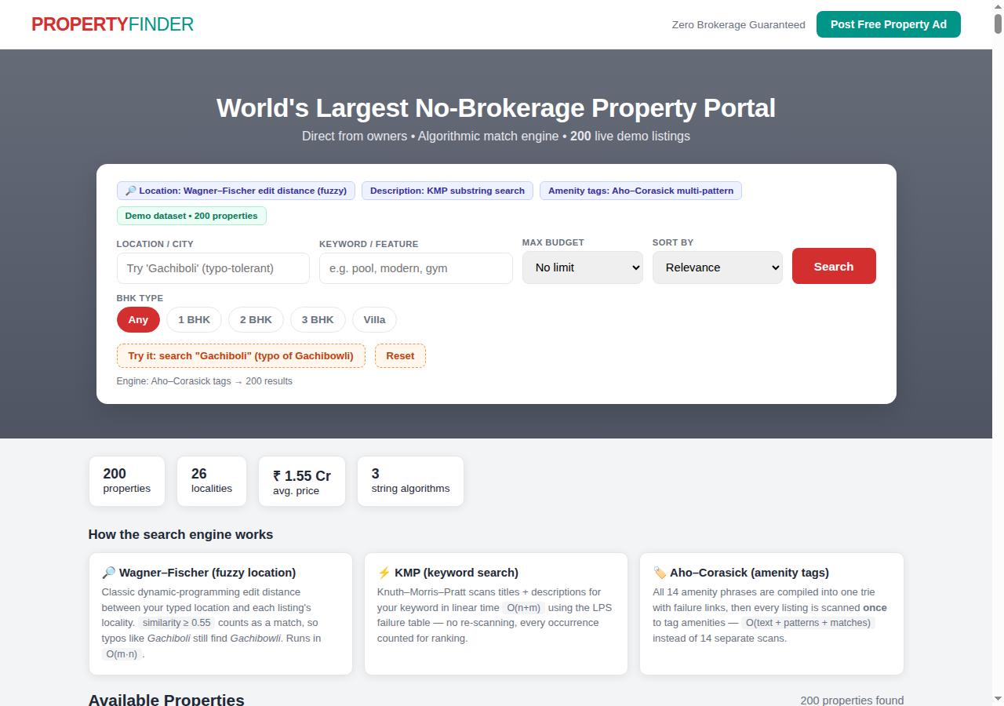
- 5.2 Deployment
- The frontend is deployed on Vercel with automatic redeploys on every GitHub push; the Spring Boot backend runs locally via mvn spring-boot:run from the folder containing pom.xml and serves the search API on port 8080.
- Fig. 5.2 Search results with match-explanation badges (fuzzy match for “Gachiboli”)
- 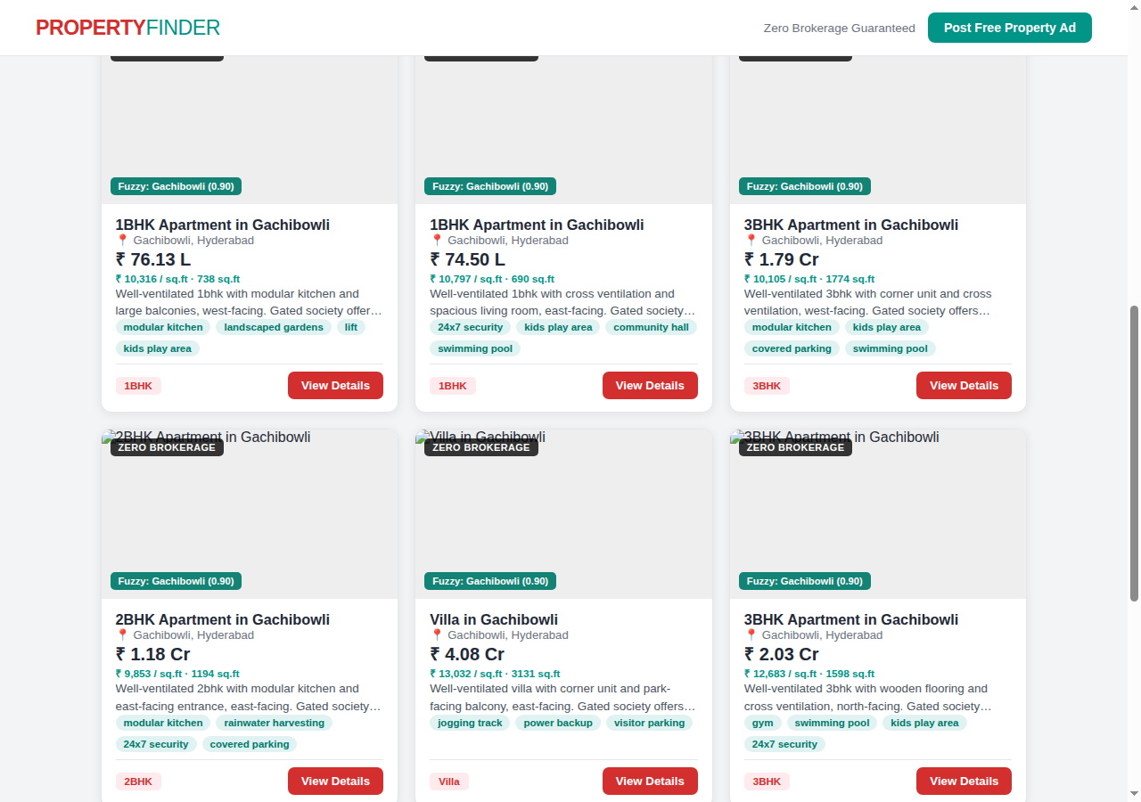
- Fig. 5.3 Property detail modal with amenity tags
- 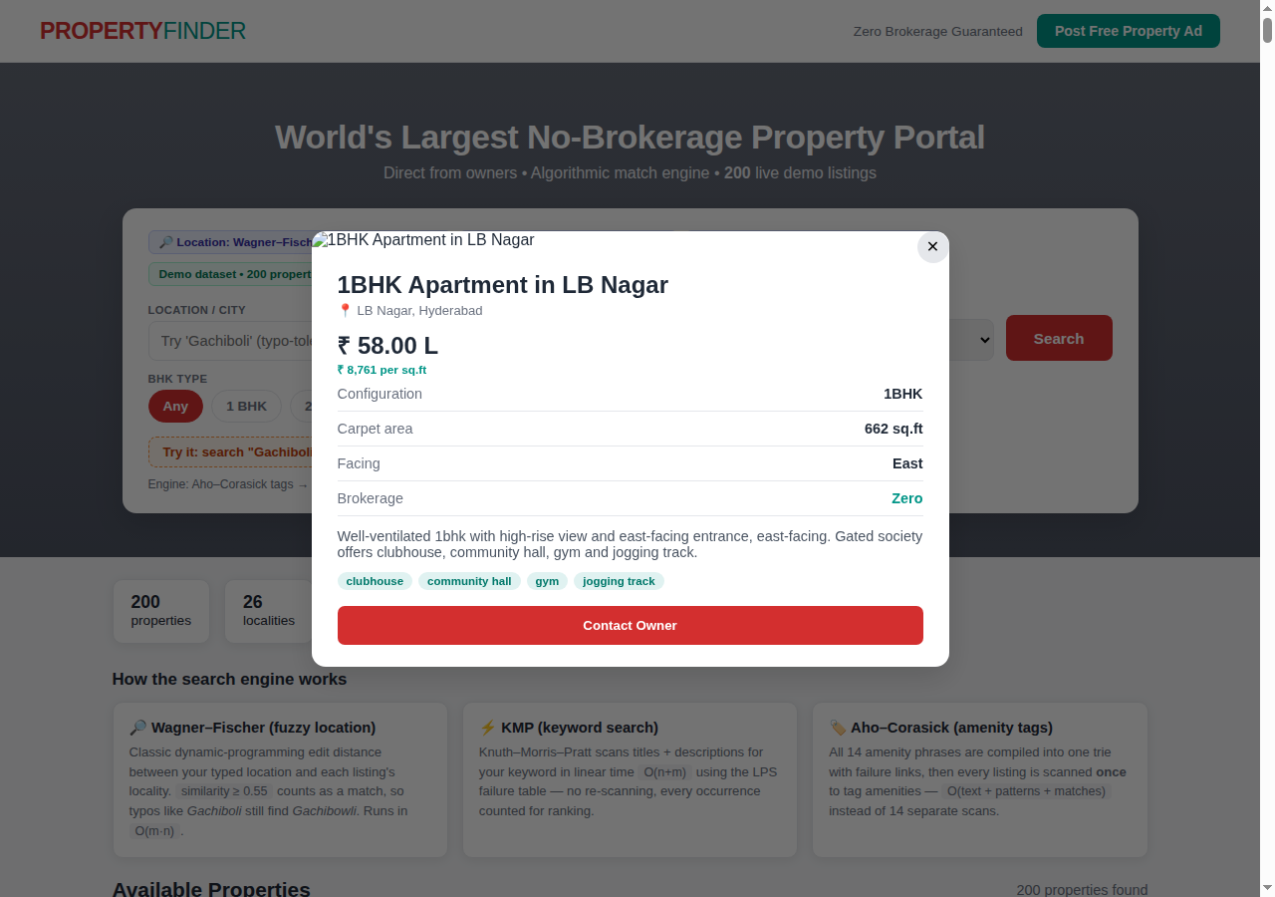
- Fig. 5.4 Contact Owner panel with owner details
- 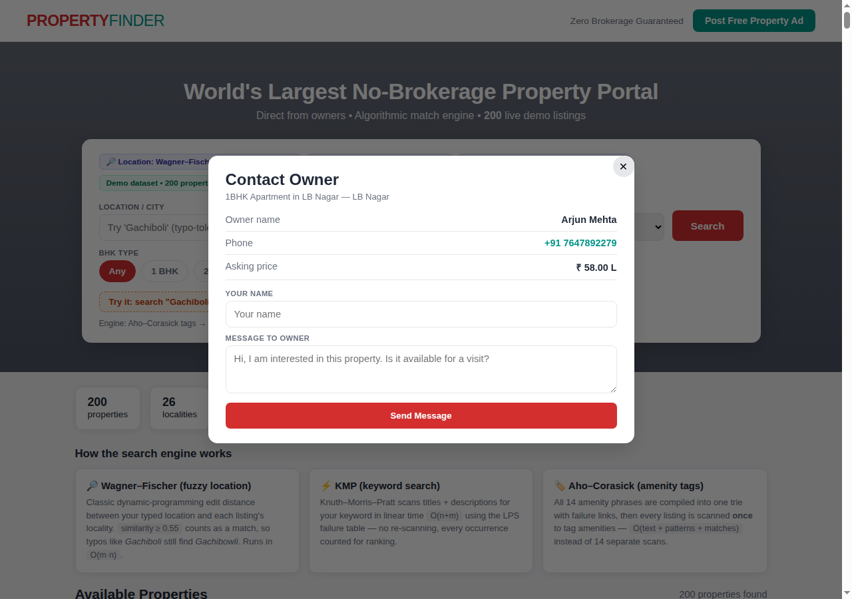
- Fig. 5.5 Post Free Property Ad form
- 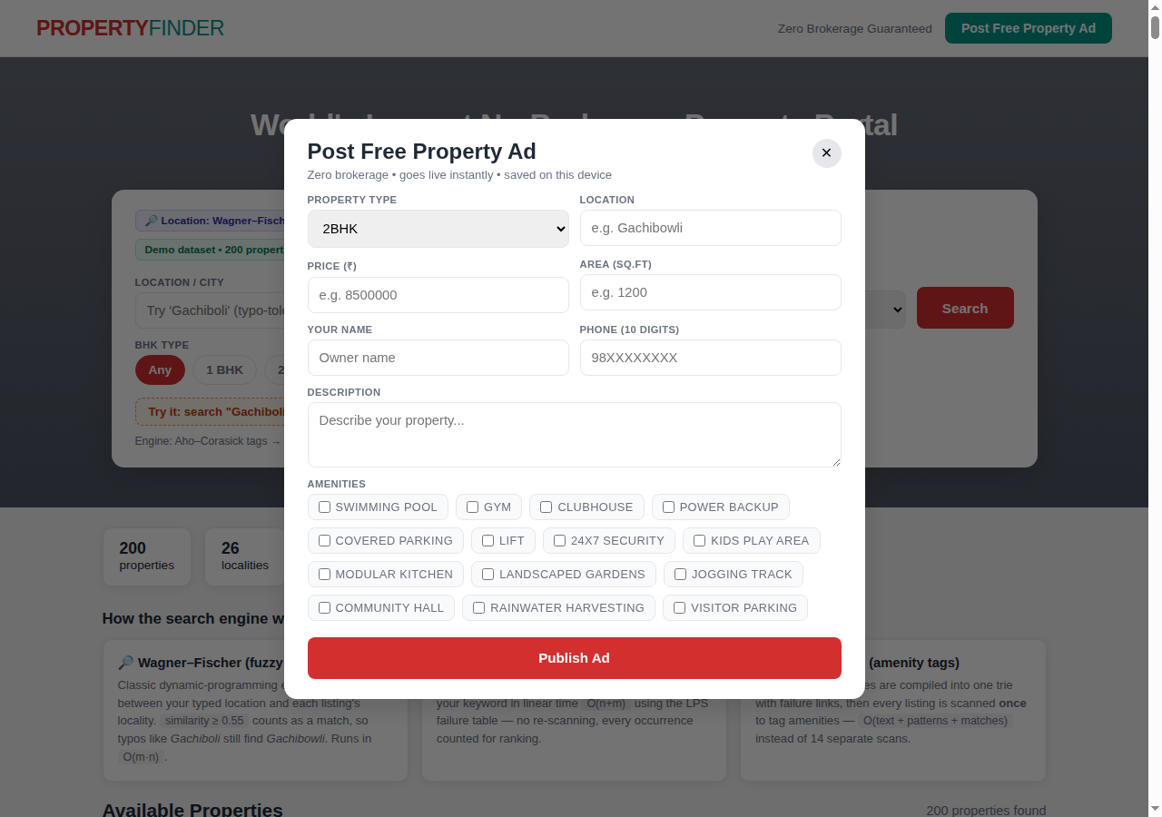
- Fig. 5.6 Keyword search results for “pool” (KMP)
- 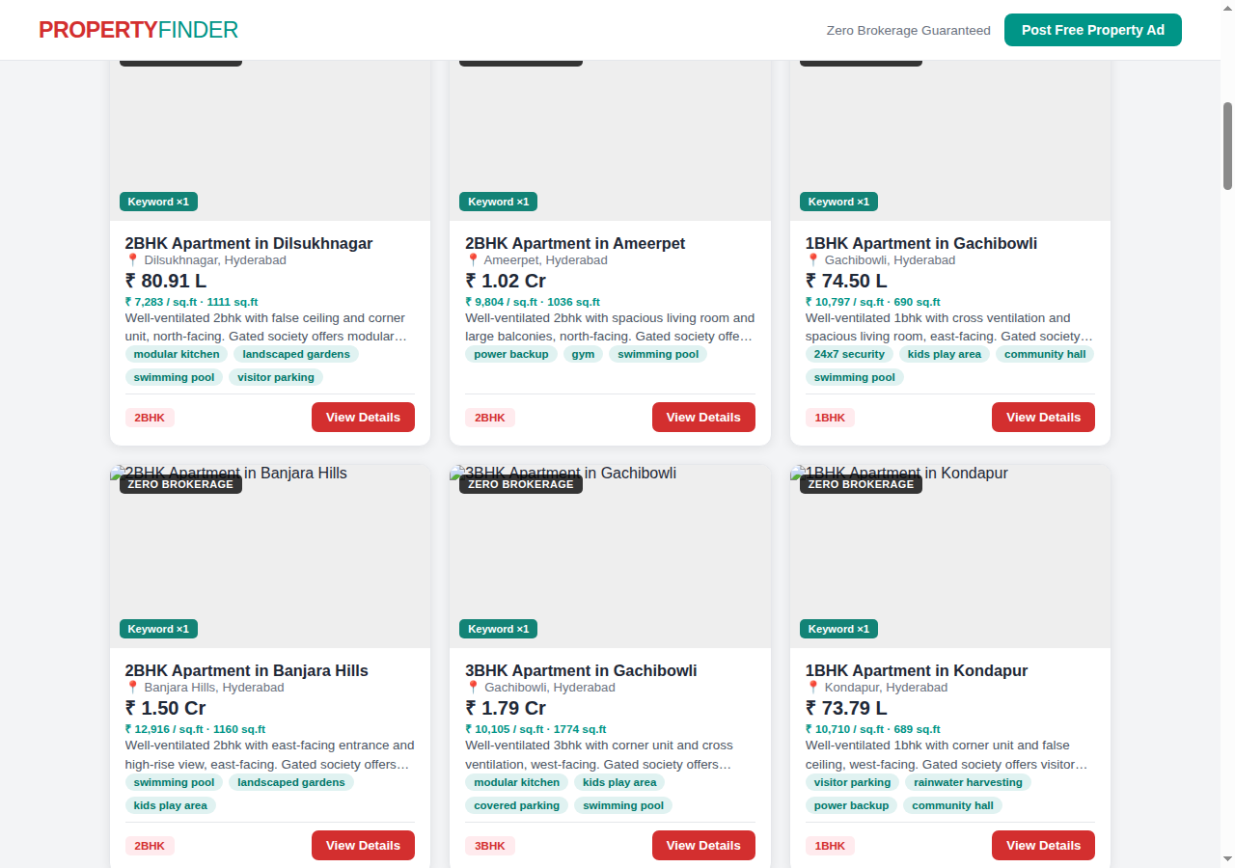
- 5.4 Screenshot Walkthrough
- Figure 5.1 shows the homepage: the brand bar, the hero with the search card, the algorithm badges that name the engine behind each field, BHK filter chips, and the one-click typo demo. Figure 5.2 shows results for the typo query “Gachiboli”: every card carries a green badge reading “Fuzzy: Gachibowli (0.90)”, which is the match explanation a user needs to trust a result they did not literally type. Figure 5.3 is the detail modal for a listing, with per-square-foot pricing, configuration rows and auto-detected amenity pills. Figure 5.4 is the Contact Owner panel with the owner's name, tappable phone number and a message form. Figure 5.5 is the Post Free Ad form with validated fields and amenity checkboxes. Figure 5.6 shows keyword results for “pool”, ranked by KMP occurrence count.
Test ID | Input | Expected behaviour | Result
T01 | Location “Gachiboli” (typo) | Match Gachibowli listings (distance 1) | Pass
T02 | Location “Madhapur” (exact) | Match only Madhapur listings | Pass
T03 | Location “Xyz” (unknown) | No listings returned | Pass
T04 | Keyword “pool” | All listings mentioning pool, ranked by hits | Pass
T05 | Keyword “POOL” (uppercase) | Same as T04 (case-insensitive) | Pass
T06 | Keyword “xyzabc” | No listings returned | Pass
T07 | Type = Villa | Only villa listings | Pass
T08 | maxPrice = 8000000 | Only listings at or below ₹80 L | Pass
T09 | Type = 2BHK + keyword “gym” | Intersection of both filters | Pass
T10 | Empty query | All 200 listings returned | Pass
T11 | Description with “swimming pool” | Amenity tag detected in one pass | Pass
T12 | Backend stopped | Frontend falls back to embedded data | Pass
- T13 — Contact Owner button opens the owner panel with name, tappable phone number and message form; submitting with an empty name shows a validation toast — PASS. T14 — Post Free Ad with an invalid phone number (fewer than 10 digits) is rejected with an explanatory message — PASS. T15 — A valid posted ad appears at the top of the listings with a “Your Ad” badge and persists after page reload via browser storage — PASS. T16 — Sorting by “Price: Low to High” reorders results monotonically — PASS.
- Each algorithm was benchmarked in Node.js over the full 200-listing dataset, averaged over 50 runs on the development machine: fuzzy location matching (whole-string plus word-level edit distance) completed in 1.57 ms, KMP keyword search over titles and descriptions in 0.47 ms, and the Aho–Corasick amenity scan in 2.19 ms — a total of about 4.2 ms per full search, comfortably within the sub-second requirement. Memory overhead is linear: the automaton holds one node per distinct trie prefix, and the edit-distance DP uses two rolling rows.
- 5.3 Performance Analysis
- To quantify KMP's advantage, character comparisons were counted on the concatenated dataset text (38,970 characters). For the keyword “pool” — whose LPS table is all zeros — naive and KMP perform almost identically (39,929 vs 39,932 comparisons), as expected: with no reusable prefix, KMP cannot skip. On a repetitive pattern (“abababY” over a periodic text), KMP performs 25,000 comparisons against the naive scan's 37,488, a 33% reduction, because each mismatch resumes from the LPS fallback instead of restarting. This confirms the theoretical claim empirically: KMP never does worse than naive, and wins exactly when the pattern contains repetition.
- 5.6 Naive vs KMP: Measured Comparison Counts
- Consider the query location=“Gachiboli”, keyword=“pool”, type=2BHK, maxPrice=12000000. Step 1 — fuzzy filter: “Gachiboli” is compared against each of the 26 locality names; editDistance(“Gachiboli”,“Gachibowli”) = 1 ≤ 2, so all Gachibowli listings survive while, for example, “Kondapur” (distance 8) is rejected. Step 2 — KMP filter: each surviving title and description is scanned for “pool”; a 2BHK listing whose description reads “…society offers power backup, modular kitchen, landscaped gardens and swimming pool” yields one occurrence. Step 3 — exact filters keep only type=2BHK and price ≤ ₹1.2 Cr. Step 4 — the Aho–Corasick pass tags [“swimming pool”, “modular kitchen”, “power backup”, “landscaped gardens”] on the survivor. The frontend then ranks by the combined score and renders the card with the badge “Fuzzy: Gachibowli (0.90)”, exactly as seen in Figure 5.2.
- 5.5 End-to-End Trace of a Sample Query
- 6. CHALLENGES AND LIMITATIONS
- The quadratic edit-distance filter is the only super-linear component, but it operates on locality strings averaging 11 characters, so its cost is negligible at this scale. Should the inventory grow to tens of thousands of listings, the natural optimisation is a BK-tree or a trigram index over locality names, reducing fuzzy lookup to O(log n) candidates before exact DP verification. The Aho–Corasick pass already scales linearly and would remain unchanged.
- 6.1 Issues Faced During Development
- Running mvn spring-boot:run from the wrong directory produced “No plugin found for prefix 'spring-boot'” — resolved by running it from the folder containing pom.xml. Browser CORS blocked the frontend's API calls until @CrossOrigin was added to the controller. On Vercel, the page cannot reach http://localhost:8080 (localhost is the visitor's machine), which motivated the offline fallback to the embedded dataset.
- Additional issues included: deployment protection on Vercel initially hid the site behind a login wall, requiring it to be disabled for public access; the page's hardcoded http://localhost:8080 API URL cannot work from the public site (localhost is the visitor's machine), which is why the offline fallback was built; and browser localStorage quotas bound how many owner-posted ads persist on a device.
- 6.2 Limitations
- The backend inventory is in-memory rather than a persistent database; fuzzy matching is limited to edit distance 2 and English text; posted ads persist only in the browser's local storage.
- Evaluation is currently functional rather than statistical: with no labelled relevance judgments, precision and recall are not measured numerically. A follow-up study could collect a query log with expected localities and report recall@k for typo queries against exact-match baselines.
- 7. CONCLUSION AND FUTURE WORK
- 7.1 Conclusion
- PropertyFinder demonstrates that classical string algorithms have direct, visible impact on a real product: Aho–Corasick turns free-text descriptions into structured amenity tags, KMP gives exact keyword search with ranking, and Wagner–Fischer edit distance makes location search tolerant of typos. The zero-brokerage portal works end to end, online against the Spring Boot backend and offline against the embedded dataset.
- 7.2 Future Work
- Persist listings in a database, add user accounts and saved searches, integrate map-based search, extend fuzzy matching to phonetic (Soundex-style) matching for Indian locality names, and deploy the backend as a container so the live-data badge works on the public site.
- Planned extensions include: persisting listings in PostgreSQL instead of in-memory storage; user accounts with saved searches and alerts; map-based locality search; phonetic (Soundex-style) matching tuned for Indian locality names; containerising the Spring Boot backend (Dockerfile.vercel workflow) so the live-data badge works on the public deployment; and a recommendation layer suggesting similar properties from amenity-tag overlap.
- Automaton: an abstract machine that reads input symbols and changes state; the Aho–Corasick structure is a trie-shaped automaton. Edit distance: the minimum number of insertions, deletions and substitutions turning one string into another. Failure link: in Aho–Corasick (and analogously the KMP LPS table), the fallback edge followed on mismatch, pointing to the longest proper suffix that is also a prefix of some pattern. LPS table: for each pattern position, the length of the longest proper prefix which is also a suffix. Precision/recall: standard retrieval metrics; this project prioritises recall on location (typo tolerance) and precision on keywords (exact match). Trie: a tree where each edge is labelled with a character and each root-to-node path spells a prefix of some stored string. Zero-brokerage: a listing model where owners publish directly and no intermediary commission is charged.
- APPENDIX A — GLOSSARY
- Example: GET /api/properties/search?location=Gachiboli&keyword=pool&maxPrice=12000000 returns 2BHK-and-under listings near Gachibowli mentioning “pool”, with the fuzzy location match applied before the keyword filter. All parameters are optional; an empty query returns the full inventory of 200 listings.
Method & Path | Parameters | Response
GET /api/properties/search | location (optional): locality, typo-tolerant | JSON array of Property objects
 | keyword (optional): exact substring | each with auto-detected amenities
 | type (optional): 1BHK/2BHK/3BHK/Villa
 | maxPrice (optional): number
- APPENDIX B — API REFERENCE
- The amenities array is the human-curated ground truth used at generation time; the detectedAmenities field populated at query time by the Aho–Corasick pass is expected to match it, which is how the T11 test case is validated. Owner names and phone numbers are synthetic placeholders for the demo dataset — in production they would come from the owner registration flow behind the Post Free Ad form.
- }
- "phone": "+91 9820012345"
- "owner": "Amit Patel",
- "amenities": ["swimming pool", "gym", "power backup", "covered parking"],
- "facing": "east",
- "areaSqft": 1180,
- "description": "Well-ventilated 2bhk with modular kitchen and large balconies, east-facing. Gated society offers swimming pool, gym, power backup and covered parking.",
- "price": 10890000,
- "type": "2BHK",
- "location": "Kondapur",
- "title": "2BHK Apartment in Kondapur",
- "id": 42,
- {
- Each of the 200 listings is a flat record with ten fields. Below is one representative record (id 42, a 2BHK in Kondapur), shown as stored in the dataset:
- APPENDIX C — SAMPLE LISTING RECORD
REFERENCES
- A. V. Aho and M. J. Corasick, “Efficient string matching: An aid to bibliographic search,” Communications of the ACM, vol. 18, no. 6, pp. 333–340, 1975.
- D. E. Knuth, J. H. Morris, and V. R. Pratt, “Fast pattern matching in strings,” SIAM Journal on Computing, vol. 6, no. 2, pp. 323–350, 1977.
- V. I. Levenshtein, “Binary codes capable of correcting deletions, insertions, and reversals,” Soviet Physics Doklady, vol. 10, no. 8, pp. 707–710, 1966.
- R. A. Wagner and M. J. Fischer, “The string-to-string correction problem,” Journal of the ACM, vol. 21, no. 1, pp. 168–173, 1974.
- Spring Framework Documentation, “Spring Boot Reference Guide,” https://spring.io/projects/spring-boot, 2026.
- Vercel Documentation, “Deployments and Projects,” https://vercel.com/docs, 2026.
- R. Buyya et al., “Cloud computing and emerging IT platforms: Vision, hype, and reality for delivering computing as the 5th utility,” Future Generation Computer Systems, vol. 25, no. 6, pp. 599–616, 2009.
- https://azure.microsoft.com/en-us/resources/cloud-computing-dictionary/what-is-cloud-architecture

